*SOFTWARE ENGINEERING & CONCEPTS – LAB MANUAL*

BUS MANAGEMENT SYSTEM

*Sharukeshwar P 220701265*

*B.E. CSE – E : II Year*

**Contents**

Overview of the Project 2

Business Architecture Diagram 3

Requirements as User Stories 4

Architecture Diagram depicting the 5

Test Strategy 6

Deployment Architecture of the application 7

# Project Overview

* **The Problem**

The survey conducted by our team involving the management of college buses revealed a significant amount fo problems with numerous people, especially students coming up with a variety of stories such as missing buses in a very short interval of time, overflowing buses due to the crowd, especially on the weekends, poor infrastructure and much more.

The question that we felt should be raised was when private travel agencies, like **redbus, goibibo, yatra.com**, etc. who are popular among the public, can provide a good service for quite a reasonable price, why can’t **private instituitions**, who charge a large amount of money separately to provide buses to students and give them a good service and experience. Hence, we have taken up this project, or lets say, this problem and strive towards providing solutions.

* **The Data**

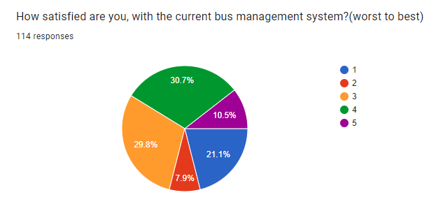

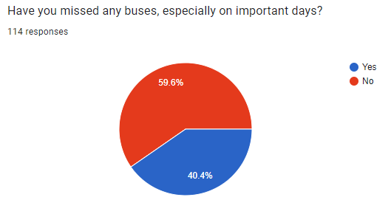

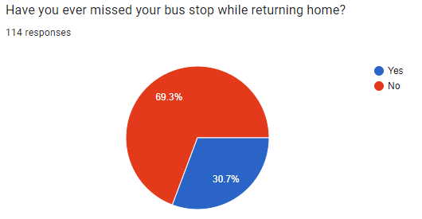

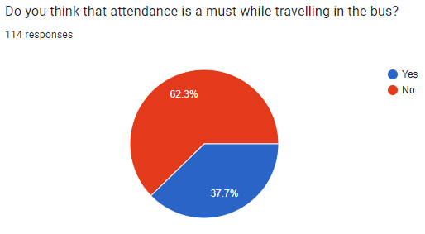

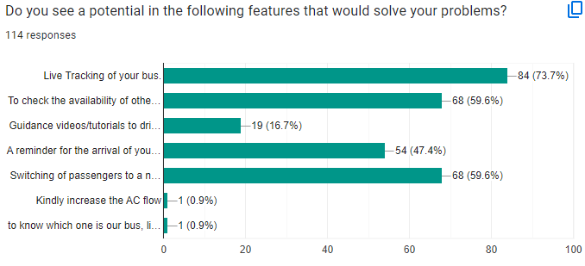

* **The Benefits**

Users, especially the students and the faculties using this system can be benefitted by the various features that we provide to solve the problems being faced so far. First things first that the people need is a **Live Tracking System**, for them to view the location of the buses in real time. This feature, when implemented can turn into a very useful thing. Then we have and **Attendance Automation System** for the attendance taken in the bus, because the manual entries include a lot of proxies. Another feature that’d potentially end the issue of crowded buses is our **Bus Switching Feature**, that would transfer the crowd, i.e., the people who are standing to a nearby bus in the vicinity. There are more of such benefits solving problems whose magnitude ranges from small to critical.

Business Architecture

* **Business need of the project**

Implementing a Bus Management System for a college addresses several critical needs related to transportation efficiency, safety, and user convenience. The goal is to streamline bus operations, enhance safety, and provide real-time information to students, faculty, and staff.

* **The current process (Manual) : How it works**
* **Route Planning :** College administration manually plans and updates bus routes and schedules based on historical data and static assumptions.
* **Tracking :** There is no real-time tracking; students and staff rely on fixed schedules, often leading to uncertainty about bus arrival times.
* **Attendance :** Attendance is recorded manually in a book, opening gates for a lot of proxies and misinformation.
* **Communication :** Notifications about delays or route changes are communicated through bulletin boards, emails, or phone calls, often leading to delays in information dissemination
* **Emergency Management :** In emergencies, bus drivers or students must manually contact the college administration, which can delay response times.

* **Personas and their current experiences**

**1. Students**

**Current Experience:**

**Uncertainty:** Students often wait at bus stops without knowing the exact arrival time of the bus.

**Missed Buses:** Due to lack of real-time updates, students may miss the bus or arrive late to classes.

**Manual Attendance:** Participation in manual attendance processes, which are time-consuming and intrusive.

**Desired Improvements:**

**Real-Time Tracking:** Ability to track bus location and receive timely notifications.

**Automated Attendance:** Streamlined attendance process without manual intervention.

**2. Faculty and Staff**

**Current Experience:**

**Inconsistent Information:** Similar to students, they face uncertainty regarding bus schedules and arrivals.

**Communication Issues:** Inadequate communication about delays or changes affects their planning and punctuality.

**Desired Improvements:**

**Reliable Information:** Access to reliable and real-time bus schedules and notifications.

**Efficient Commuting:** More predictable and efficient commuting experience.

**3. College Administration**

**Current Experience:**

**Resource Intensive:** Significant time and resources spent on managing transportation manually.

**Inaccurate Data:** Errors in manual data entry for attendance and route management.

**Emergency Response:** Delayed response times in case of emergencies due to lack of integrated communication systems.

**Desired Improvements:**

**Operational Efficiency:** Automated and integrated system to reduce manual workload.

**Accurate Data:** Reliable and real-time data for better decision-making.

**Improved Safety:** Faster and more effective emergency response capabilities.

**4. Bus Drivers**

**Current Experience:**

**Communication Gaps:** Inefficient communication with administration and students regarding schedule changes and emergencies.

**Desired Improvements:**

**Effective Communication:** Better tools for communicating with the administration and handling route changes or emergencies.

- **Overall business problems**

**1. Inefficiency**

**Manual Processes:** Time-consuming and error-prone manual processes for route planning, attendance, and communication.

**Resource Allocation:** Inefficient allocation of resources due to lack of real- time data and automation.

**2. Lack of Real-Time Information**

**Uncertainty:** Students and staff face uncertainty regarding bus arrival times, leading to inconvenience and missed classes.

**Delayed Responses:** Delays in communication and emergency response due to the lack of integrated, real-time systems.

**3. Communication Challenges**

**Fragmented Systems:** Inefficient communication channels resulting in delayed or missed notifications.

**Emergency Management:** Slow and ineffective emergency management processes, compromising safety.

**4. Data Accuracy and Security**

**Manual Errors:** High potential for errors in manual data entry for attendance and route management.

**Data Privacy:** Challenges in ensuring data privacy and security with manual and fragmented systems.

- **Business Architecture Diagram**

# Requirements as User Stories

* A minimum of 10 user stories excluding the login user story in the same as told in the theory class
* Estimates using the Poker planning methodology for above
* A minimum of 3 NFR’s

# Architecture Diagram depicting the

* + different modules, their interactions, error handling, logging, data storage etc
  + Architecture pattern used and why
  + Design principles used and why
* Class diagrams
  + For all entities described in the Business Architecture Diagram, their relationships with other entities
  + Should depict the different attributes and its methods
* Sequence diagram for atleast 5 of the user stories documented above

# Test Strategy

* Document the Test Plans
* Test cases for atleast 5 user stories showcasing the Happy Path and the Error Scenarios
* A view of the github repository showcasing the Project structure, their naming conventions
* A view of their DevOps Architecture for their respective project and the associated tools used in Azure

# Deployment Architecture of the application